**POSTMAN**

**INTEGRATIONS**

**TESTING**

<http://localhost:8080/api/product> - SEARCHING PRODUCT - ALL ROLES CAN ACCESS

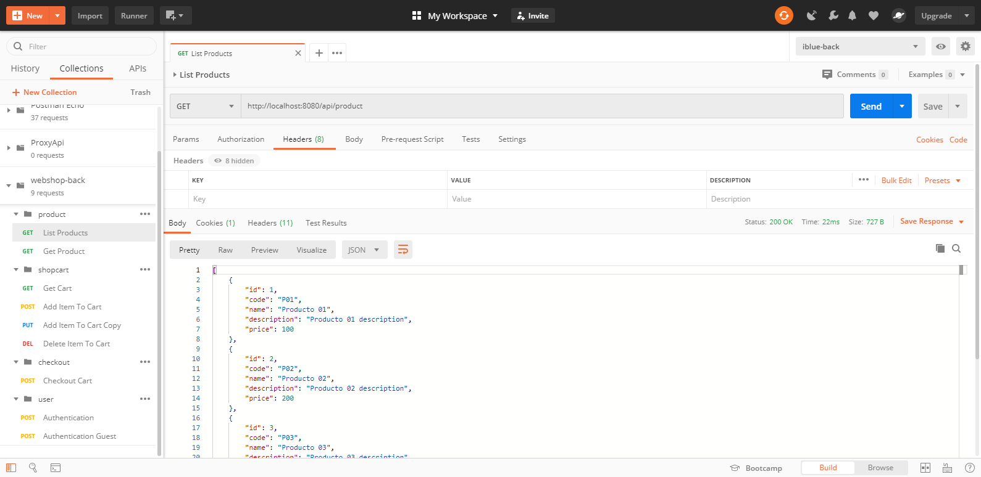

<http://localhost:8080/api/product/2> - SEARCHING PRODUCT BY ID - ALL ROLES CAN ACCESS

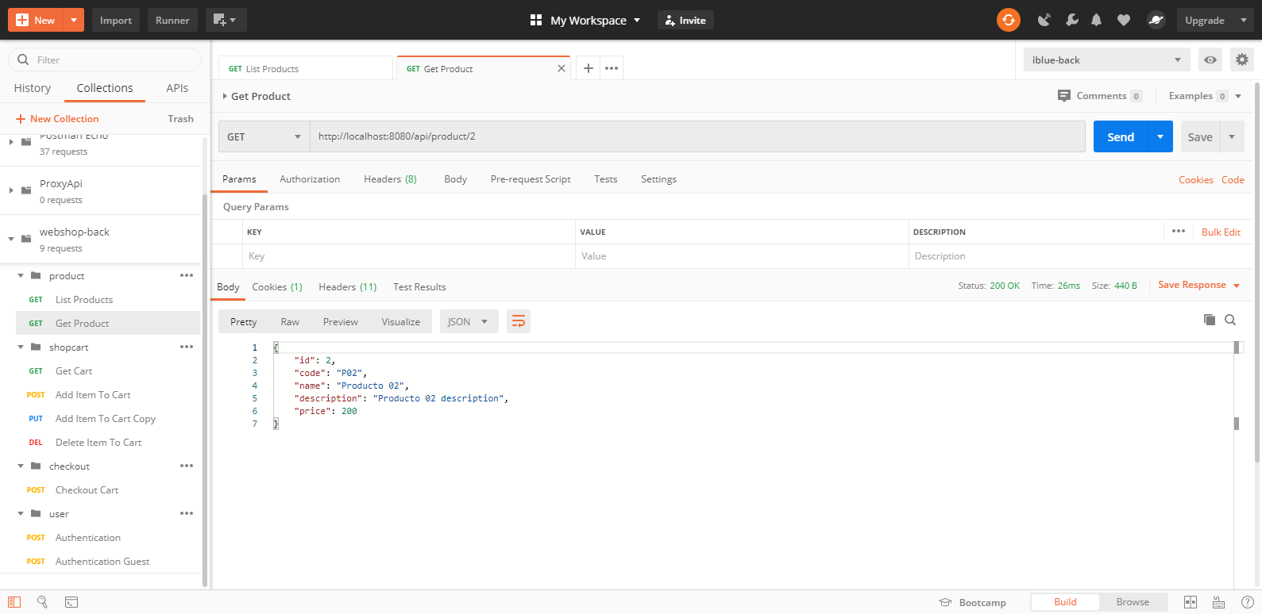

<http://localhost:8080/api/cart> - ADD ITEM AND GENERATE TOKEN (BODY)

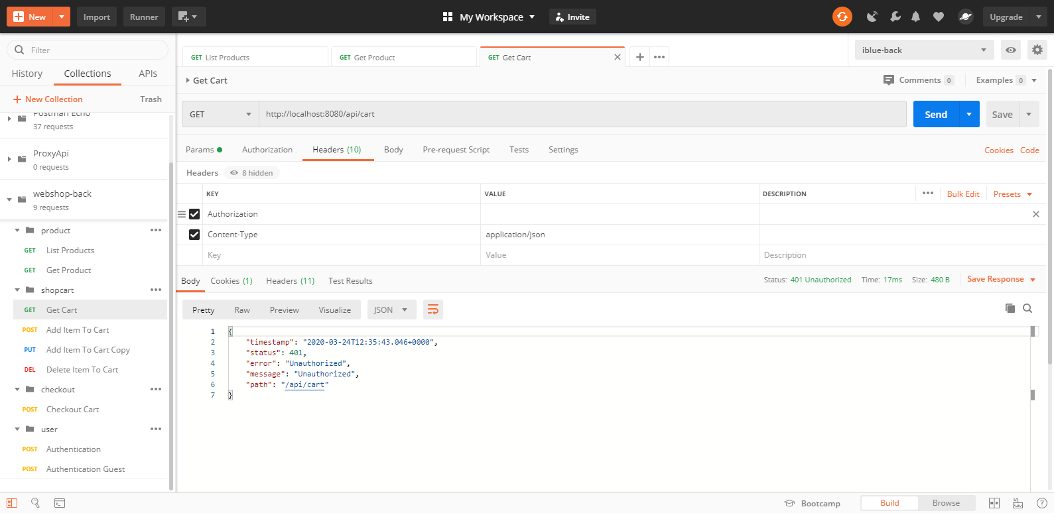

<http://localhost:8080/api/cart/item> - ADD ITEM AND GENERATE TOKEN

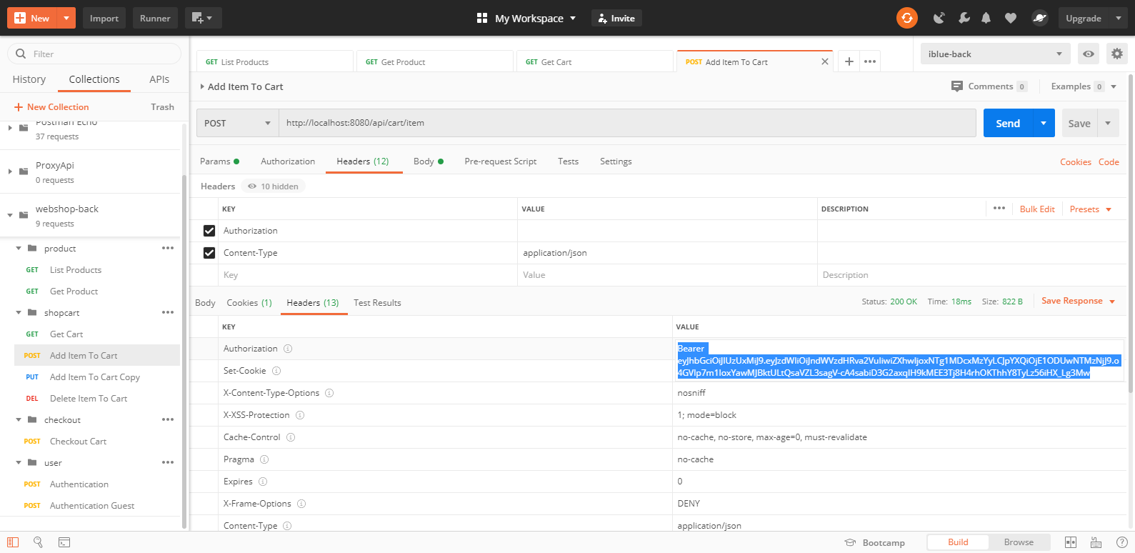

<http://localhost:8080/api/cart/item> - UPDATE ITEM WITHOUT TOKEN

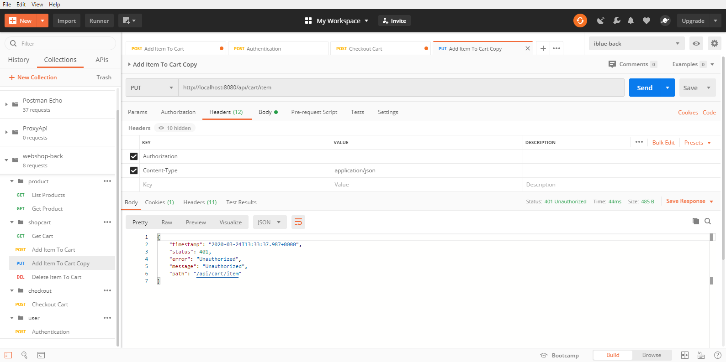

<http://localhost:8080/api/cart/item> - UPDATE ITEM. ACCESS WITH TOKEN OF “GUEST USER” OR “REGISTERED USER”

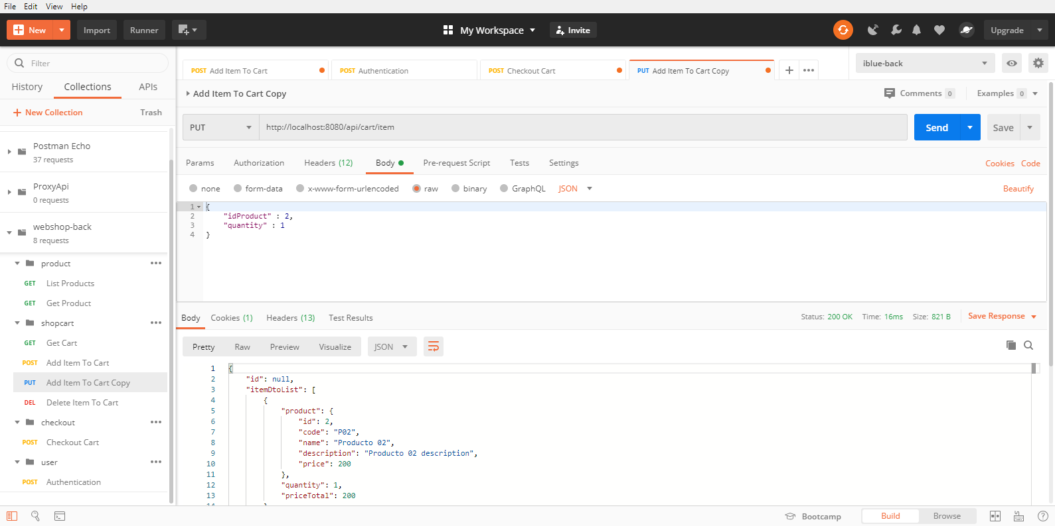

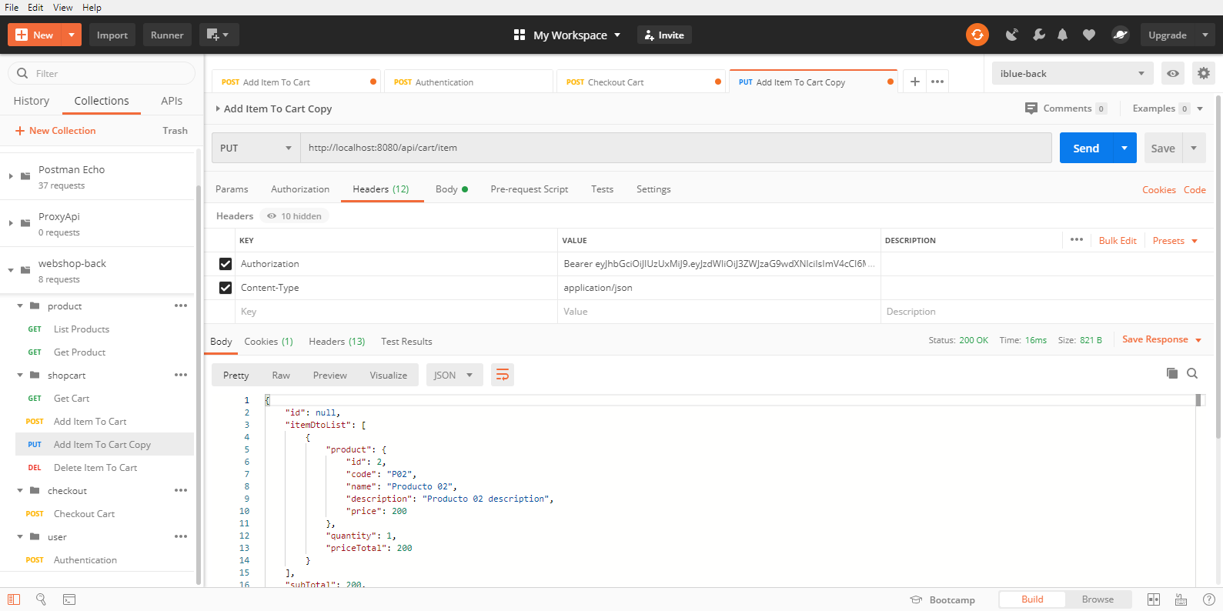

<http://localhost:8080/api/cart/item?idProduct=2> DELETE ITEM WITHOUT TOKEN

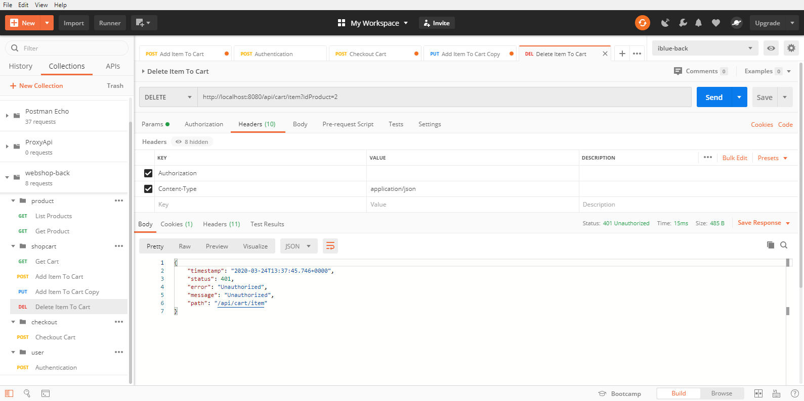

<http://localhost:8080/api/cart/item?idProduct=2> – DELETE ITEM. ACCESS WITH TOKEN OF “GUEST USER” OR “REGISTERED USER”

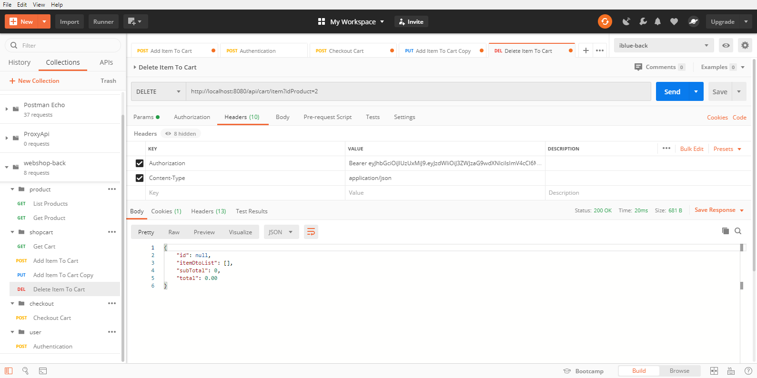

<http://localhost:8080/api/checkout> - CHECKOUT WITHOUT TOKEN

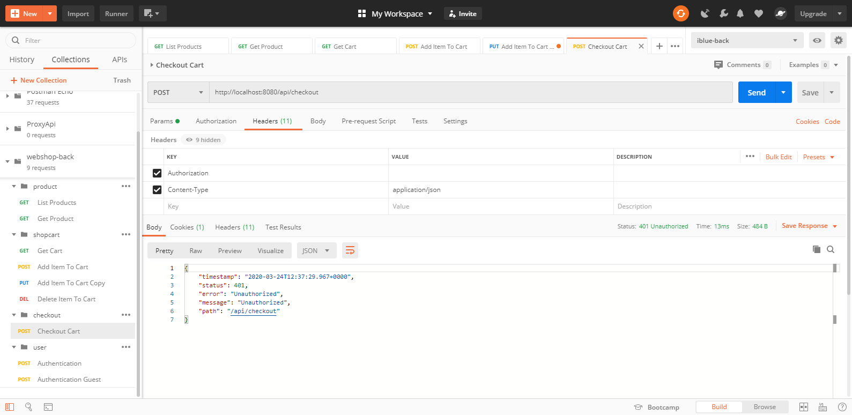

<http://localhost:8080/api/checkout> - CHECKOUT WITH TOKEN “GUEST USER”

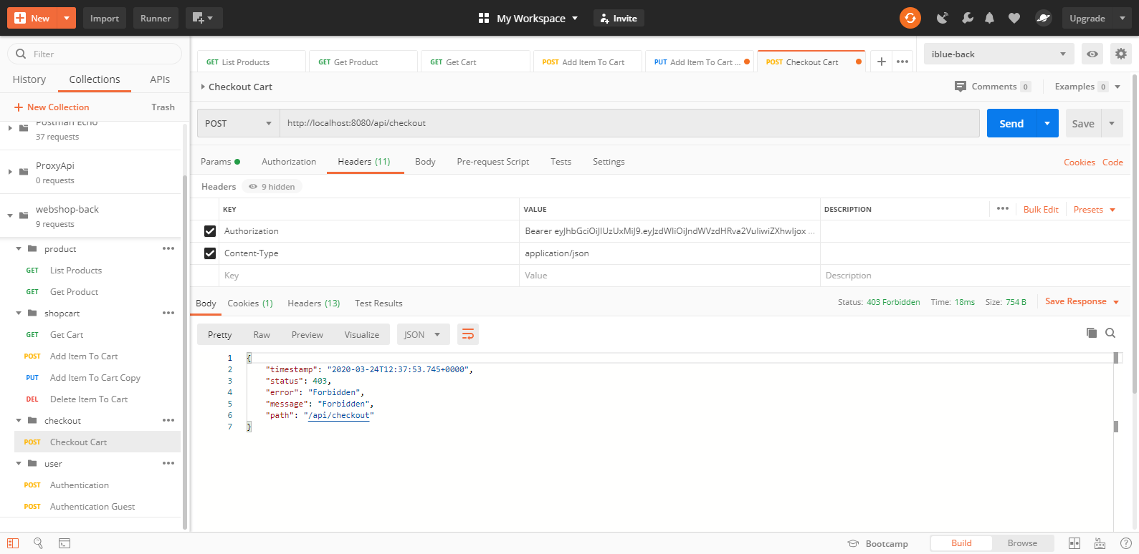

<http://localhost:8080/authenticate> - REGISTERED USER LOGIN

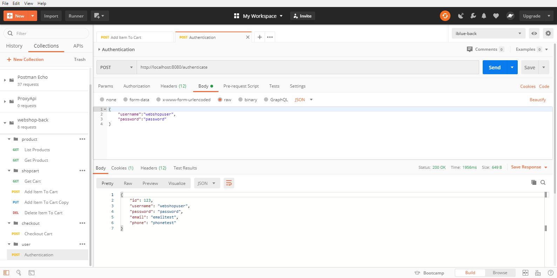

<http://localhost:8080/authenticate> - REGISTERED USER TOKEN

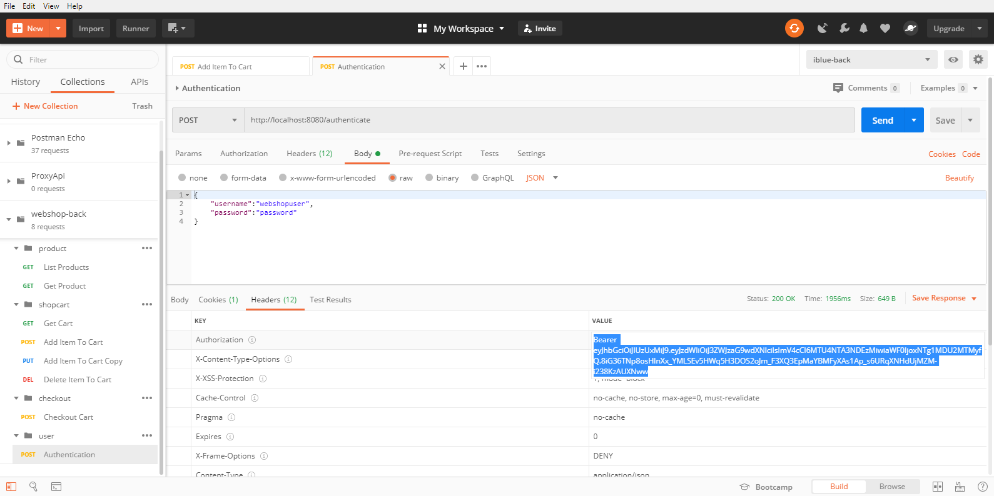

<http://localhost:8080/api/cart/item> - ADD ITEM WITH REGISTERED USER WITH TOKEN

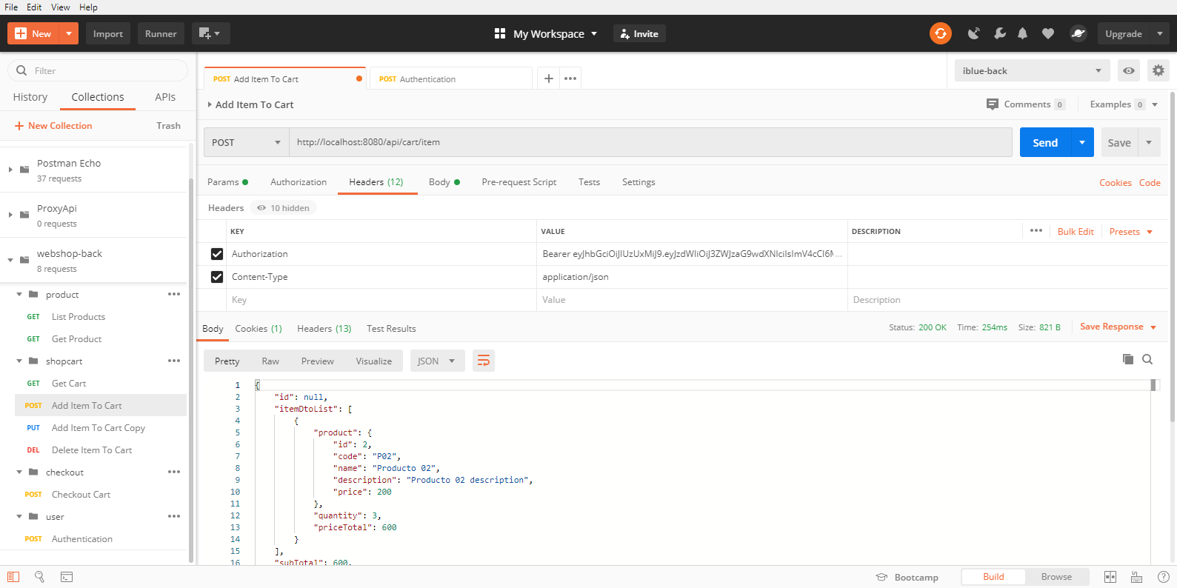

<http://localhost:8080/api/checkout> - CHECKOUT CART WITH REGISTERED USER

